Tissue-engineered peripheral nerve improved by dynamic culture of a thermosensitive collagen hydrogel
Tuesday 19 August 2014 - 1am PST
Tissue engineering technologies offer new treatment strategies for the repair of peripheral nerve injury, but cell loss between seeding and adhesion to the scaffold remains inevitable.
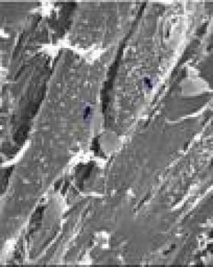
In the composite constructed with the thermosensitive collagen hydrogel, the cells on the longitudinal section were arranged parallelly and well distributed (scanning electron microscope).
Credit: Neural Regeneration Research
In a study reported in Neural Regeneration Research (Vol. 9, No. 14, 2014), a thermosensitive collagen hydrogel remained as a liquid when kept at temperatures below 10°C and gelled when the temperature was increased to 37°C in an incubator for 30 minutes, which was used as an extracellular matrix and combined with bone marrow mesenchymal stem cells to construct tissue-engineered peripheral nerve composites in vitro.
Results from DNA analysis and scanning electron microscope indicate that tissue-engineered composites formed with thermosensitive collagen hydrogel in dynamic culture can maintain larger numbers of seeded cells by avoiding cell loss during the initial adhesion stage; moreover, seeded cells are well-distributed throughout the material, which is of great significance for in vitro construction of tissue-engineered peripheral nerve composites.
Article: " Dynamic culture of a thermosensitive collagen hydrogel as an extracellular matrix improves the construction of tissue-engineered peripheral nerve," by Lanfeng Huang1, Rui Li2, Wanguo Liu3, Jin Dai1, Zhenwu Du4, Xiaonan Wang1, Jianchao Ma1, Jinsong Zhao5 (1 Department of Joint Surgery, Orthopedics Hospital of the Second Hospital of Jilin University, Changchun, Jilin Province, China; 2 Centre of Hand & Foot Surgery and Reparative & Reconstructive Surgery, Orthopedics Hospital of the Second Hospital of Jilin University, Changchun, Jilin Province, China; 3 Department of Orthopedics Surgery, the Third Hospital of Jilin University, Changchun, Jilin Province, China; 4 Institute of Orthopedics, the Second Hospital of Jilin University, Changchun, Jilin Province, China; 5 Department of Ophthalmology, the Second Hospital of Jilin University, Changchun, Jilin Province, China)
Huang LF, Li R, Liu WG, Dai J, Du ZW, Wang XN, Ma JC, Zhao JS. Dynamic culture of a thermosensitive collagen hydrogel as an extracellular matrix improves the construction of tissue-engineered peripheral nerve. Neural Regen Res. 2014;9(14):1371-1378.

